**USER**

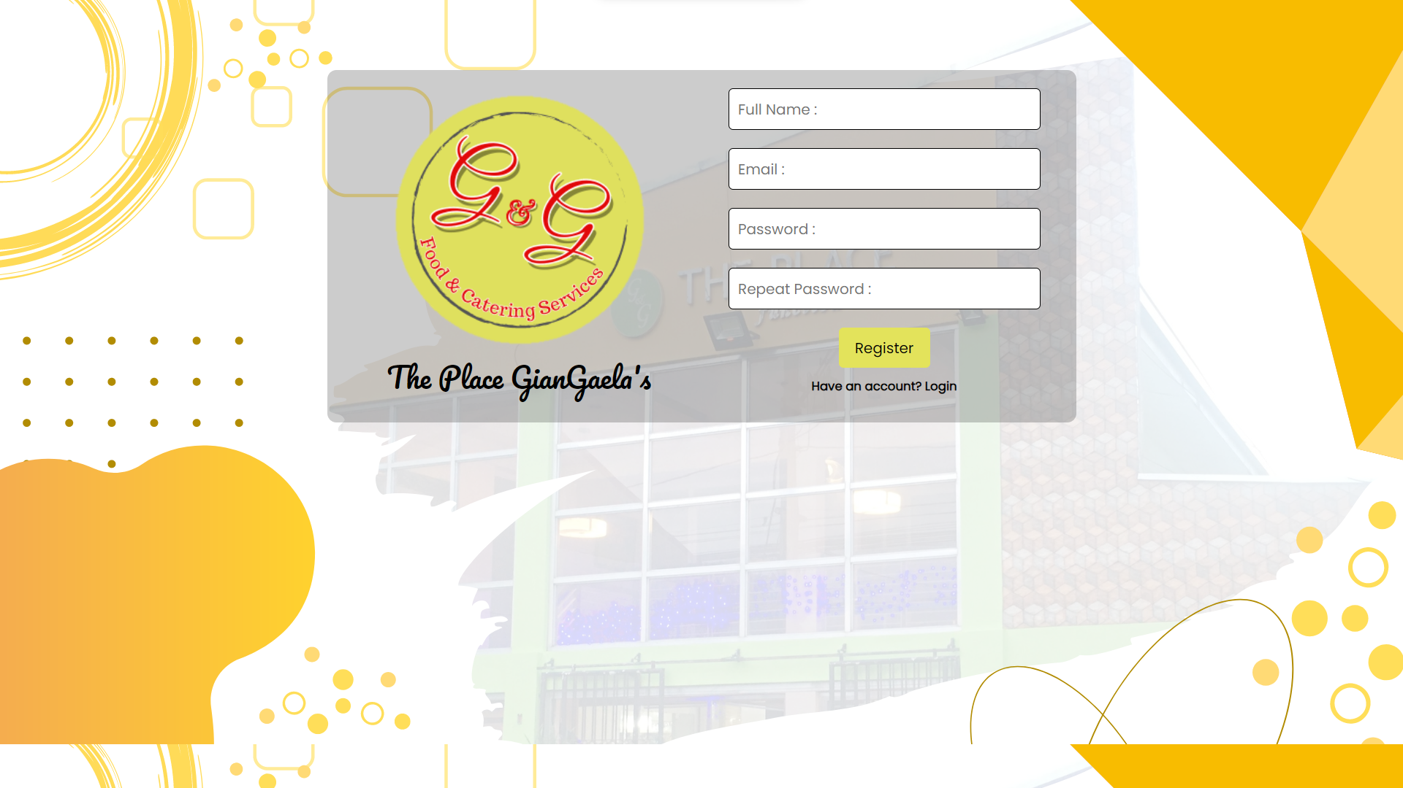

**REGISTER PAGE**

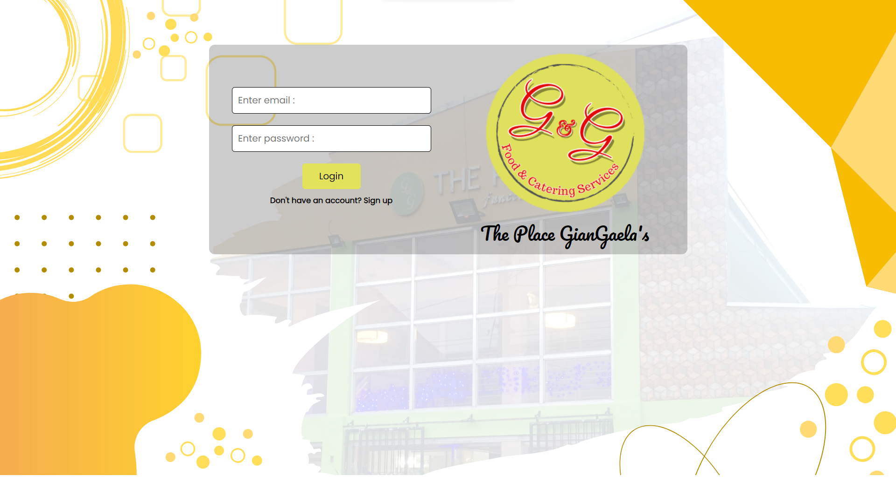

**LOGIN PAGE**

-login and registration page with forgot password function, saka lang mag reregister/login si user pag mag bbooked na sya ng catering service.

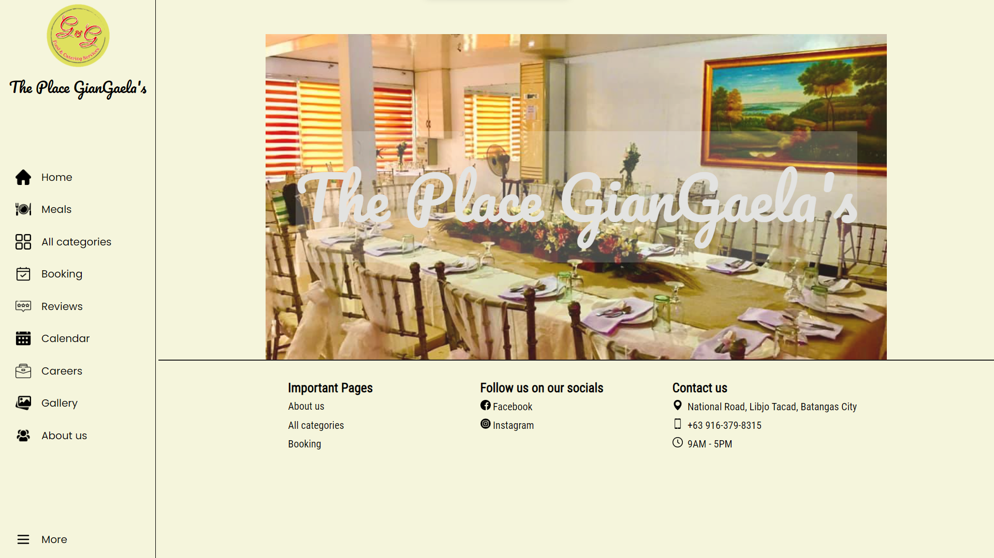

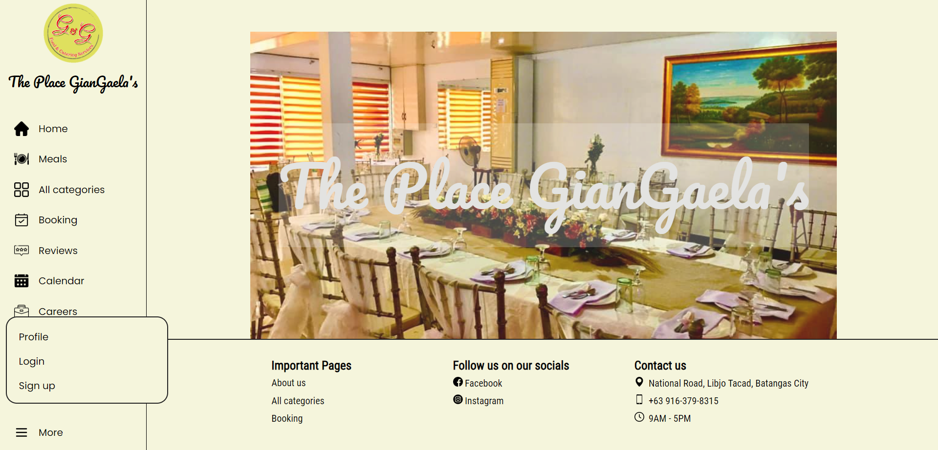

**HOME PAGE**

-home page

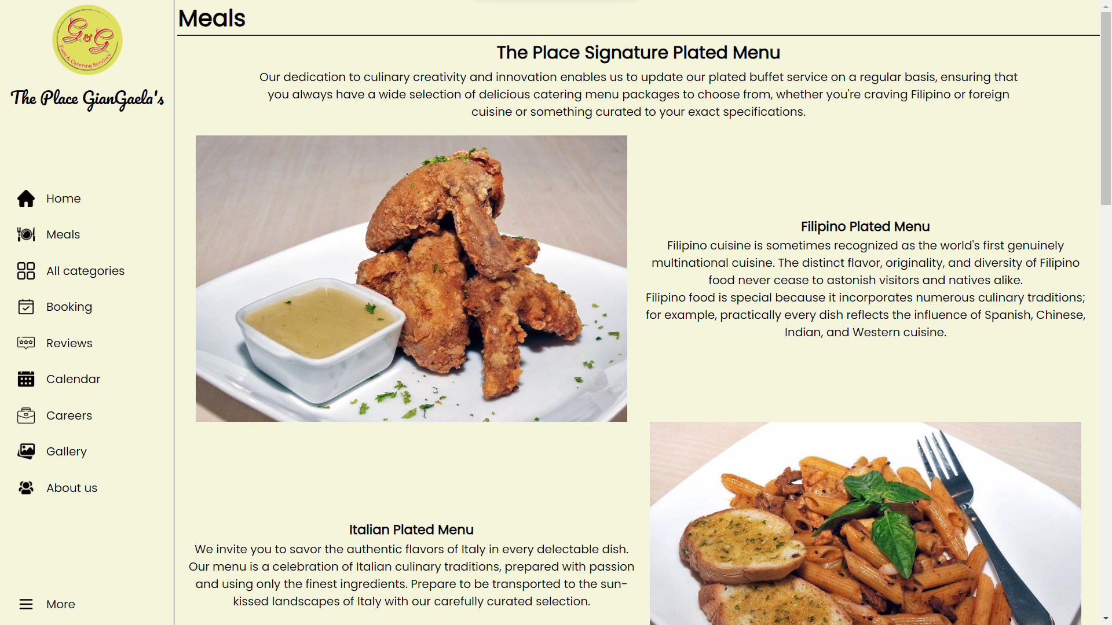

**MEALS PAGE**

-meals page, included here yung mga signature plated menu ni the_place_g&g

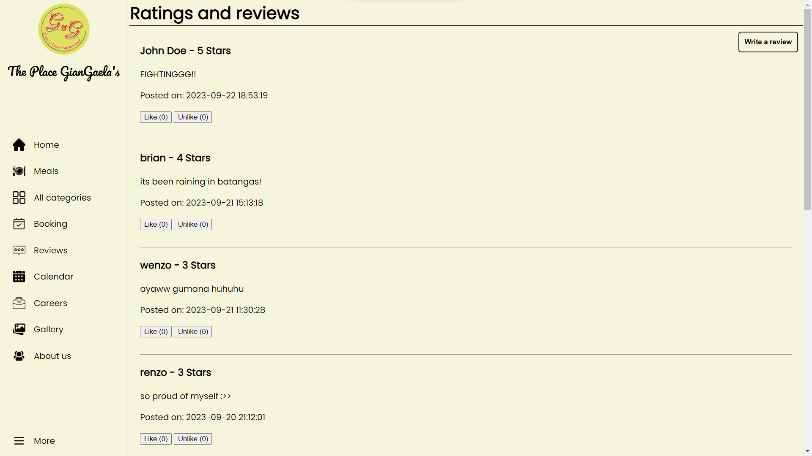

**RATING AND REVIEW PAGE**

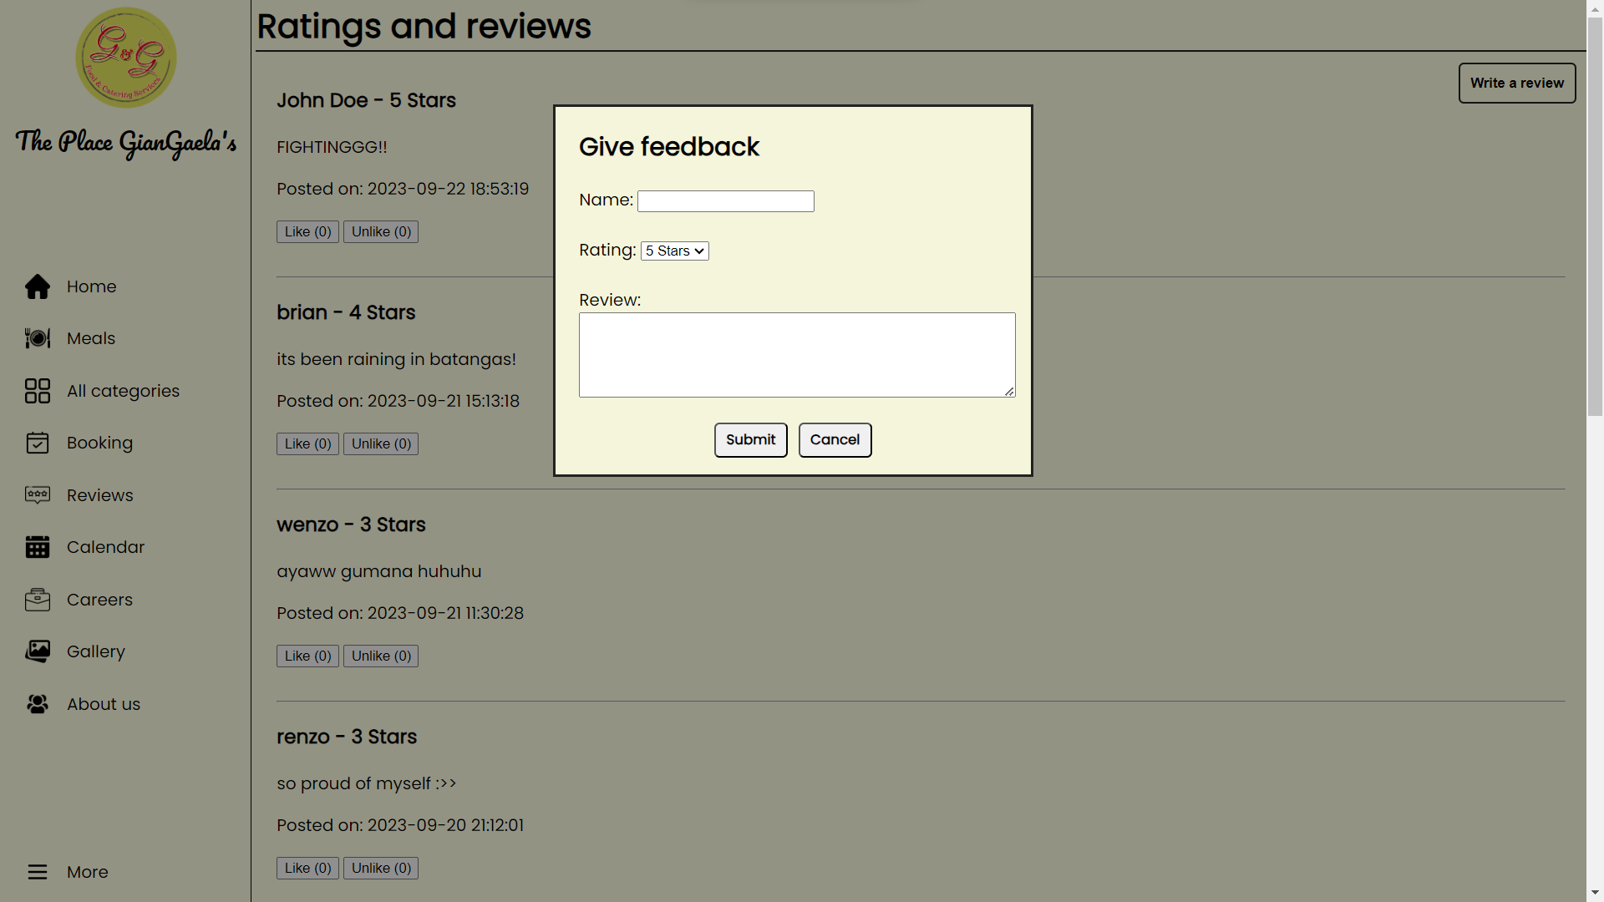

**GIVE FEEDBACK POP-UP MODAL**

-review page, included here yung mga nag bbigay ng feedback the_place_g&g kung masarap ba yung foods, kung maganda ba yung services nila sa mga cutomers nila and meron din na feature na pede mag like or unlike si user dun sa nababasa nila na reviews. Included din dito na pede sila mag bigay ng feedback.

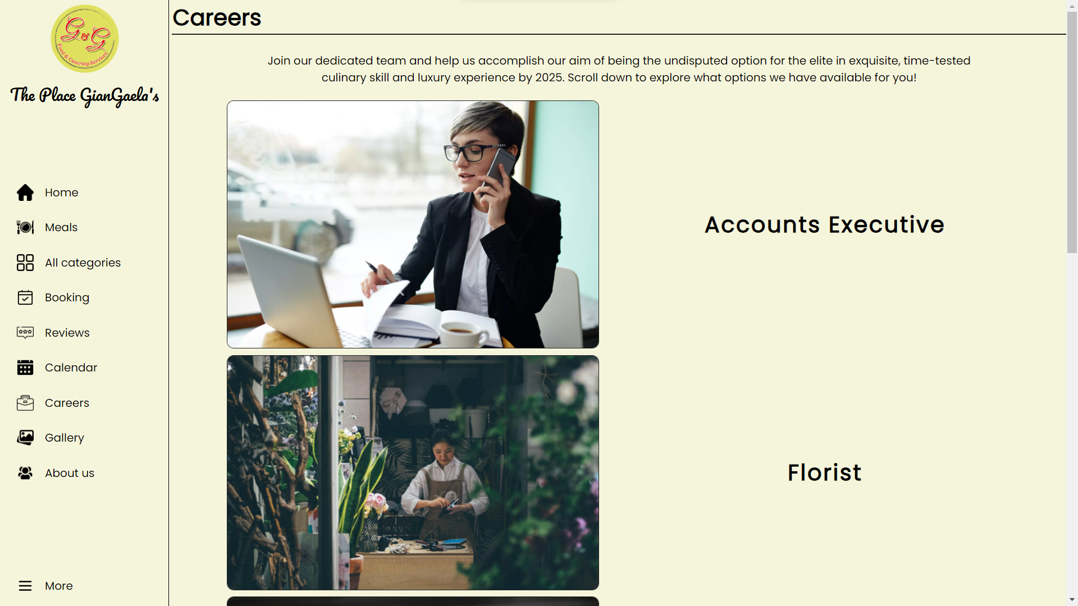

**CAREER PAGE**

Included dito yung mga available jobs na pede pag aplyan ni user.

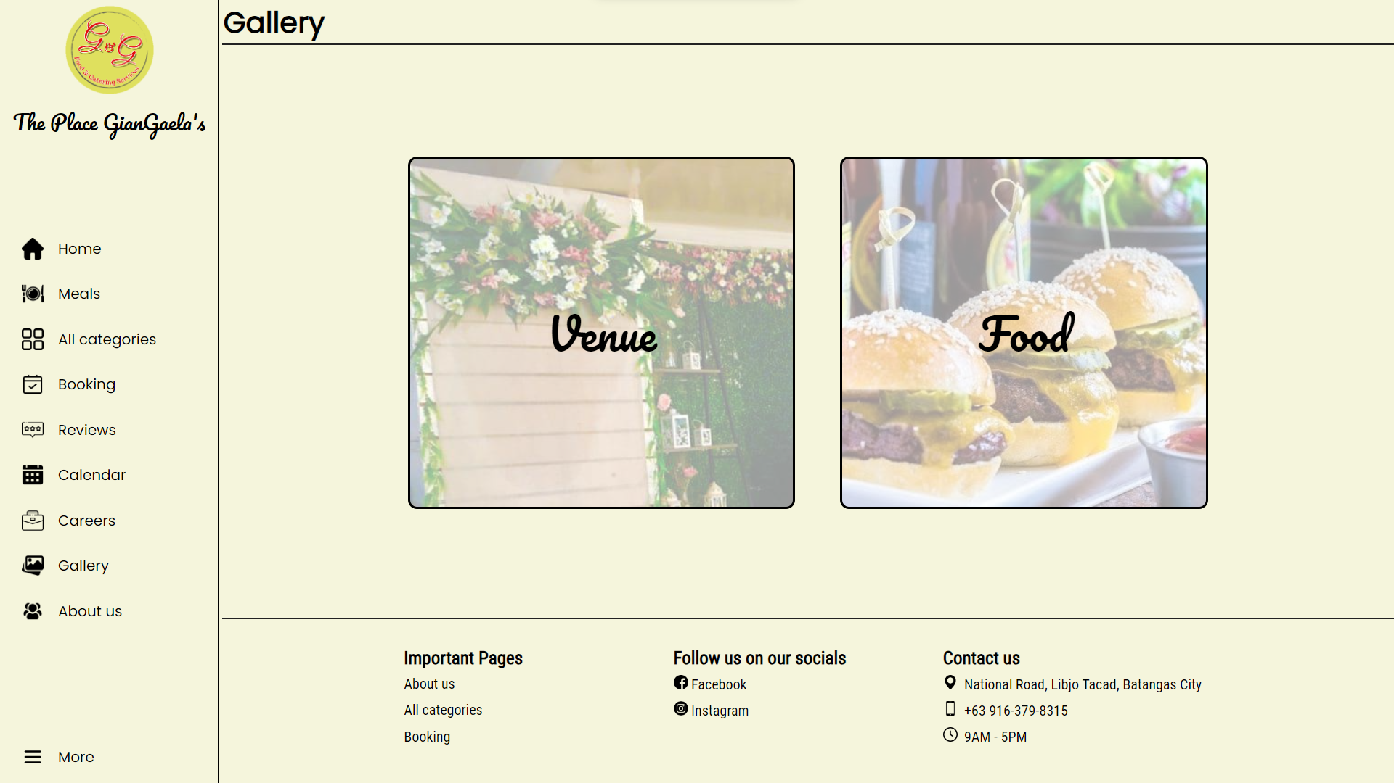

**GALLERY PAGE**

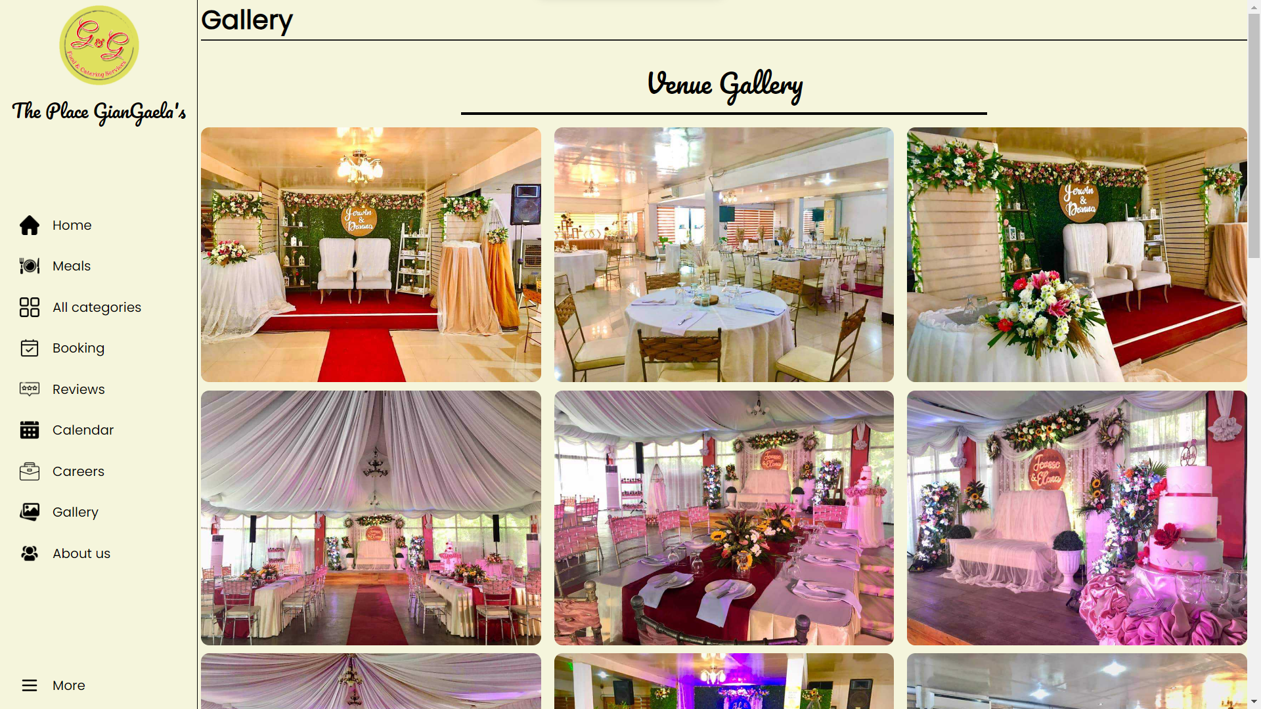

**VENUE GALLERY PAGE**

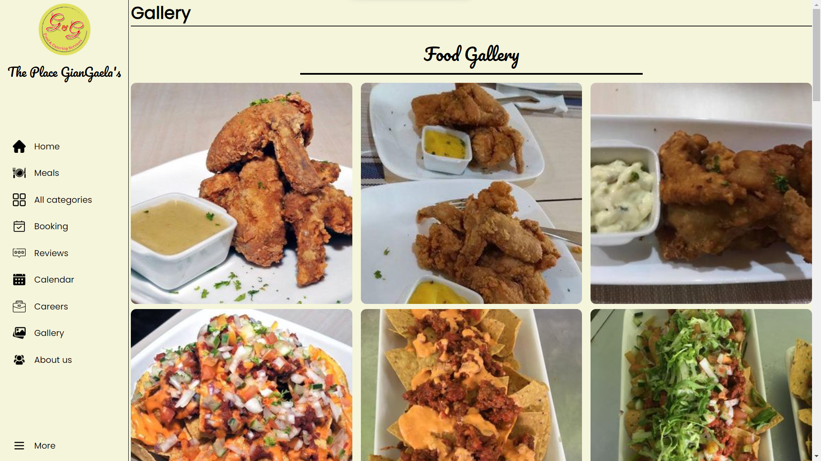

**FOOD GALLERY PAGE**

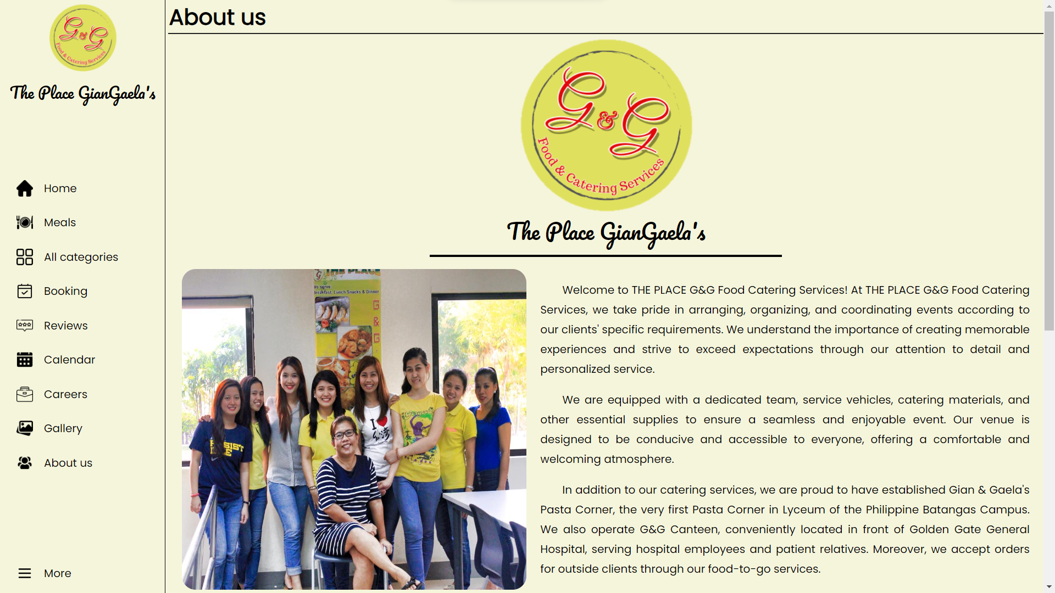

**ABOUT US PAGE**

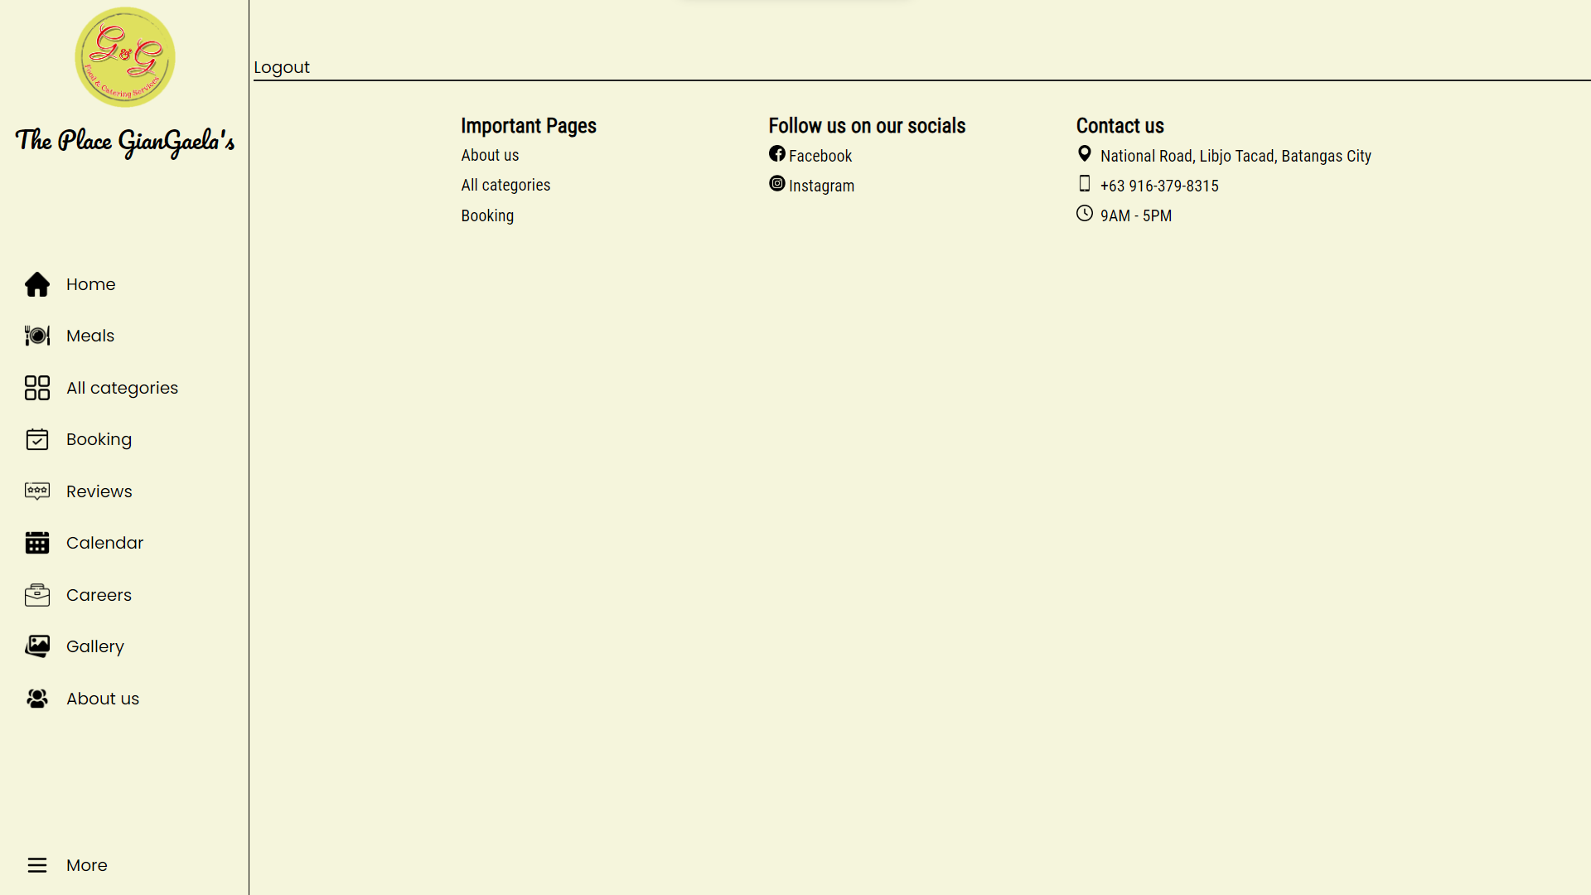

**PROFILE PAGE**

Included naman dito yung account details such us fullname. Then yung booking nila kung nagbooked ba sila sa system. Then logout function dito rin included.

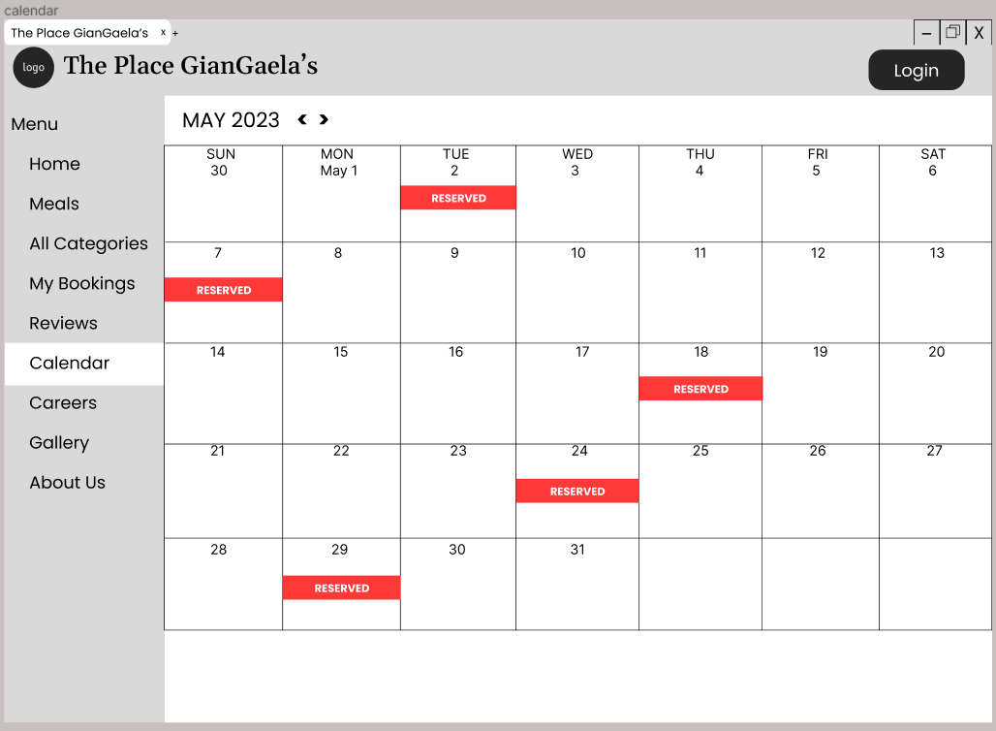

**CALENDAR PAGE**

Included naman dito yung mga date na available pa, and yung mga date na may booking na.

**BOOKING PAGE**

Main function ng system then andito na rin yung payment method once na mag bbooked na sila.

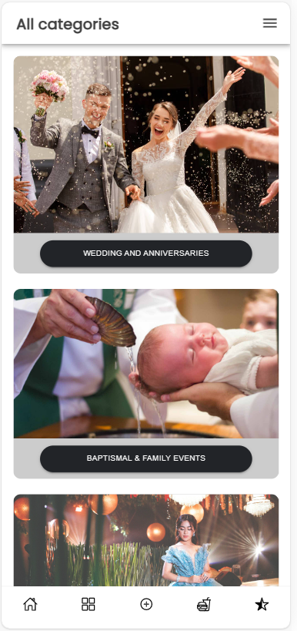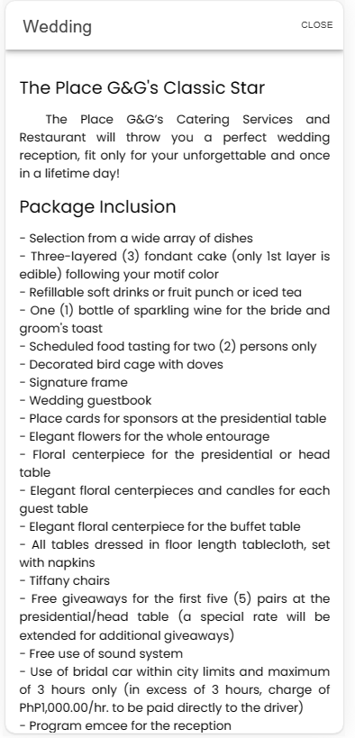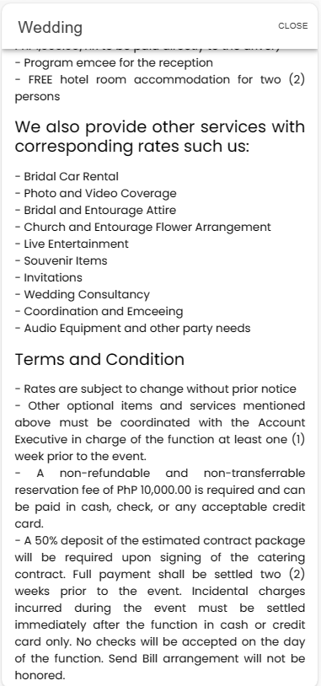

**ALL CATEGORIES**

Andito yung mga packages na in-ooffer ng the_place_g&g such as weedings, debuts, christening/ baptismal, birthday parties, corporate events, or any events. Then may special feature na search bar, once na mag input si user ng certain amout (ex. 50,000) lalabas yung mga packages na pasok dun sa amount nay un.

**ADMIN**

**LOGIN PAGE**

Different link login page sa user login but same design.

**DASHBOARD -BOOKING**

Dito makikita yung details ng mga nag pa booked ng catering services.

**RATING AND REVIEWS**

Sa admin pede rin nila makita yung mga nag bibigay ng feedback sa kanila

**CALENDAR**

Ganun din sa calendar, admin can also view the calendar kung ano-anong date na ba yung naka reserved